**Project Details and Status:**

**Pre-requisites:**

1. Python3 – flask and pandas
   1. Install python3 and pip3 (if not installed during python3 install. Check by running the below commands)
   2. Install flask, pandas by running **pip3 install flask** and **pip3 install pandas** in terminal

**Project folder structure:**

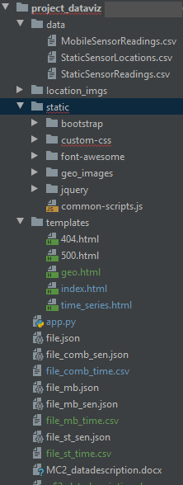

**Running the app:**

Execute below commands in the terminal in project root folder (project_dataviz)

1. **export FLASK_APP=app.py**
2. **flask run**

The program will run and and it will display the url in terminal. Click it or copy/paste it in a browser (preferably on chrome).

**Completed tasks:**

1. Data Analysis
2. Developed application server to clean, transform the data and serve the visualizations along with data
3. Developed application front-end base structure
4. Develop a structured generic code to implement bar graphs using D3JS
5. Develop a structured generic code to implement line and time-series graphs using D3JS
6. Data ETL (Extract, Transform, Load) and integration for visuals

**Available Visuals:**

1. Sensor Readings Analysis
   1. For all the sensors (static and mobile combined)
   2. For static sensors
   3. For mobile sensors
2. Time Series Analysis
   1. For all the sensors (static and mobile combined)
   2. For static sensors
   3. For mobile sensors

Geo Analysis is in progress.

**Questions and Answers:**

1. Visualize radiation measurements over time from both static and mobile sensors to identify areas where radiation over background is detected. Characterize changes over time.

**Ans:** In the visualizations 1 and 2, the number of measurements received from the mobile sensors are quite high compared to the stationary ones. We can overcome the anomalies in the sensor readings by combining the readings received from all the sensors from a specific location at any point of time. Compared to the mobile sensors the stationary sensors are recording quite low reading (Visualization 1). Also based on this visualization we can clearly identify the spectrum of all the sensor readings. From Visualization 2, we see that the reading values during the earthquake are quite high to conclude that the low radiation values are either anomalies in the sensor reading or low radiation at the specific location and time.

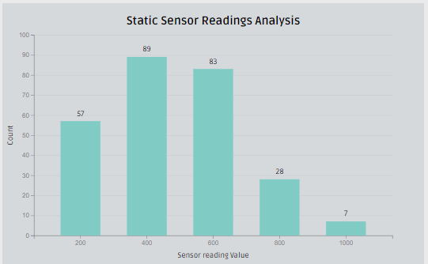

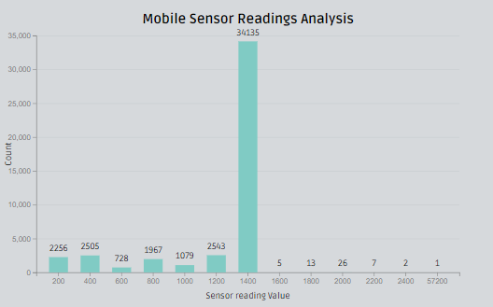

1. Use visual analytics to represent and analyze uncertainty in the measurement of radiation across the city.
2. Compare uncertainty of the static sensors to the mobile sensors. What anomalies can you see? Are there sensors that are too uncertain to trust?
3. Which regions of the city have greater uncertainty of radiation measurement? Use visual analytics to explain your rationale.
4. What effects do you see in the sensor readings after the earthquake and other major events? What effect do these events have on uncertainty?

**Ans:** From the visualizations 3, 4 we can see individual sensor reading by time period. The spikes in radiation before the earthquake can clearly be termed as noise. In the visualizations we see that there are a lot of mobile sensors that show spikes, locating the coordinates can help in tracking and decontaminating the vehicles. Using the collocated sensor readings we can eliminate the noise from the visuals.

**Static sensors’ readings:**

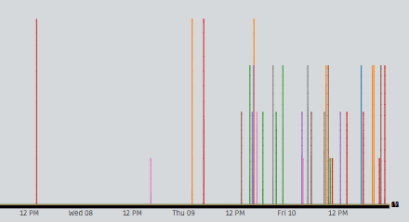

**Mobile sensors’ readings:**

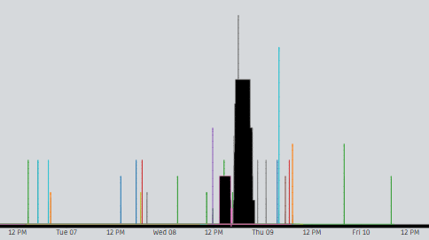

1. Given the uncertainty you observed in question 2, are the radiation measurements reliable enough to locate areas of concern?
2. Highlight potential locations of contamination, including the locations of contaminated cars. Should St. Himark officials be worried about contaminated cars moving around the city?
3. Estimate how many cars may have been contaminated when coolant leaked from the Always Safe plant. Use visual analysis of radiation measurements to determine if any have left the area.
4. Indicated where you would deploy more sensors to improve radiation monitoring in the city. Would you recommend more static sensors or more mobile sensors or both? Use your visualization of radiation measurement uncertainty to justify your recommendation.

**Ans:** The potential risk areas can be identified by plotting the coordinates of the sensors that have greater spikes with high readings. The mobile sensor readings can be used to tract the number of cars that recorded high readings in the mobile sensors. From the stats collected static sensor readings data is found to be more accurate with less noise. It can be recommended to have more static sensors in the exits of cities and around the power plants to capture the variation with more accuracy.

1. Summarize the state of radiation measurements at the end of the available period. Use your novel visualizations and analysis approaches to suggest a course of action for the city. Use visual analytics to compare the static sensor network to the mobile sensor network. What are the strengths and weaknesses of each approach? How do they support each other?

**Ans:** Most of the mobile readings do not show any sort of high readings, which can be due to lesser mobility after the earthquake. However, few of the stationary sensors show high readings whose coordinates can be located near to the power plants. Static sensors help to identify the readings of a specific location more accurately, but we have very few readings which can be improved by increasing the number of static sensors around the city. Mobile sensors are helpful to track the contaminated vehicles across the state even in the locations where there are no power plants. All the vehicles that recorded any contamination should be decontaminated. The number of static sensors should be increased in the areas of power plants.

1. The data for this challenge can be analyzed either as a static collection or as a dynamic stream of data, as it would occur in a real emergency. Describe how you analyzed the data - as a static collection or a stream. How do you think this choice affected your analysis?

**Ans:** The analysis is done using python(pandas), visualizations with d3.js and served as a Flask application. This model can be used for both static data and stream data analysis. The current analysis is done as a static data. In a real emergency the model can also be used to stream the data and get the insights in real time. By analyzing real time data, it will be helpful to take quick corrective measures to have the radiation contained.